Real Estate Management App

Real Estate Management App - Report 1
1. Introduction 1
2. Functional Features 1
2.1 Land List Screen 1
2.2 Land Detail Screen 1
2.3 Add/Edit Land Screen 2
2.4 Location Selection & Map Integration 2
2.5 Delete Land Record 2
3. Technologies Used 2
4. Implementation Details 2
4.1 Database Schema 2
4.2 Key Functionalities 3
5. How to Run the Application 3
5.1 Prerequisites 3
5.2 Adding Google Maps API Key 3
5.3 Running the Application 3
6. Screenshots 4
7. Conclusion 4

1. Introduction
The Real Estate Management App is designed to help employees efficiently collect, store, and manage land records. This application enables users to add, edit, view, and delete land details, along with integrating Google Maps for location selection and navigation.

2. Functional Features

2.1 Land List Screen
- Displays a list of all saved land properties.
- Shows essential details such as land name, price, and address.
- Provides a search bar to filter land by name or address.
- Clicking on a land item navigates to the Land Detail Screen.

2.2 Land Detail Screen
- Displays full details of the selected land property.
- Shows the location on a map using stored GPS coordinates.
- Provides Edit and Delete options.
- Navigates to Google Maps for detailed directions.

2.3 Add/Edit Land Screen
- Allows users to input or modify land details:
  - Name
  - Price
  - Address
  - GPS Coordinates (manual entry or map selection)
  - Additional details
- Includes a Save button to store changes.

2.4 Location Selection & Map Integration
- Users can choose a location by:
  - Manually entering GPS coordinates.
  - Selecting a location on an interactive map.
- The land location is displayed on Google Maps in the Detail Screen.

2.5 Delete Land Record
- Users can delete a land record from the Detail Screen.
- A confirmation dialog appears before deletion to prevent accidental removal.

3. Technologies Used
- Programming Language: Kotlin
- Database: SQLite (using SQLiteOpenHelper)
- UI Framework: Jetpack Compose
- Navigation: Jetpack Navigation Component
- Dependency Injection: ViewModel
- Networking: Retrofit (if future API integration is required)
- Google Maps API: Used for location selection and display

4. Implementation Details

4.1 Database Schema
The SQLite database consists of a single table named Land, structured as follows:
Column | Type | Description
id | INTEGER PRIMARY KEY AUTOINCREMENT | Unique land record ID
name | TEXT | Name of the land property
price | REAL | Price of the land
address | TEXT | Address of the land
latitude | REAL | Latitude coordinate
longitude | REAL | Longitude coordinate
details | TEXT | Additional details

4.2 Key Functionalities
- SQLite Database Operations: Insert, Update, Delete, Query land records.
- Google Maps Integration: Displays and selects land locations using GPS.
- Jetpack Compose UI: Dynamic UI with state management.
- Navigation Component: Manages screen transitions.

5. How to Run the Application

5.1 Prerequisites
- Android Studio installed (latest stable version recommended).
- Google Maps API Key (Needed for map functionality).

5.2 Adding Google Maps API Key
- Get an API key from the Google Cloud Console.
- Enable Maps SDK for Android in your Google Cloud project.
Open AndroidManifest.xml and add the API key inside the <application> tag:
<meta-data
android:name="com.google.android.geo.API_KEY"
- android:value="YOUR_API_KEY_HERE"/>
- Replace YOUR_API_KEY_HERE with your actual API key.

5.3 Running the Application
- Clone the repository or extract the provided ZIP file.
- Open the project in Android Studio.
- Connect an Android device or use an emulator.
- Click Run (Shift + F10) to install and launch the application.

6. Screenshots
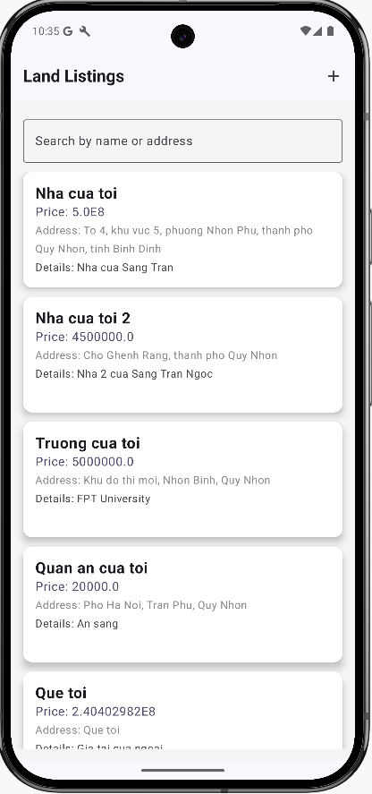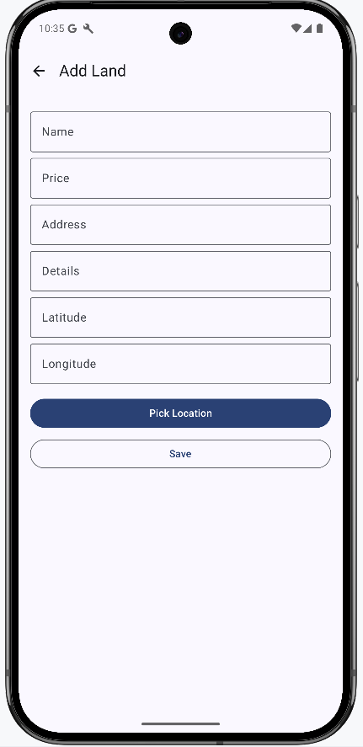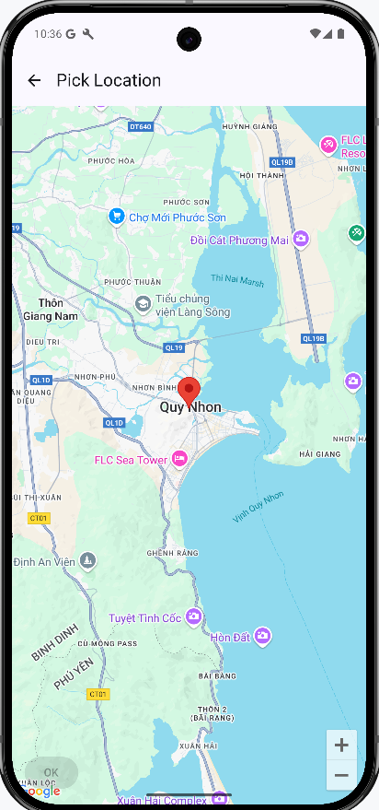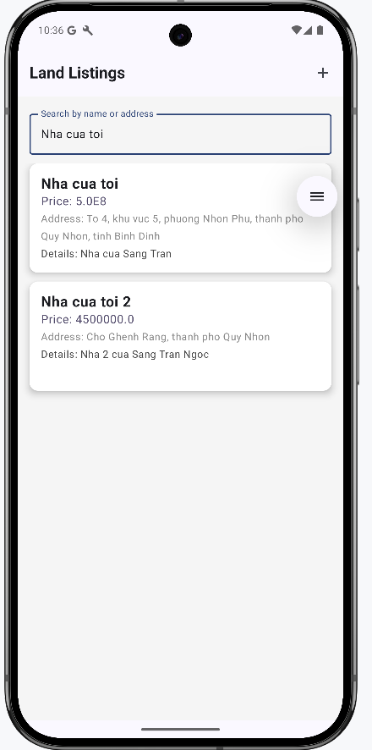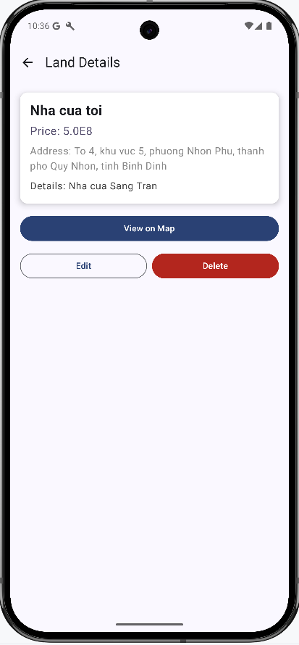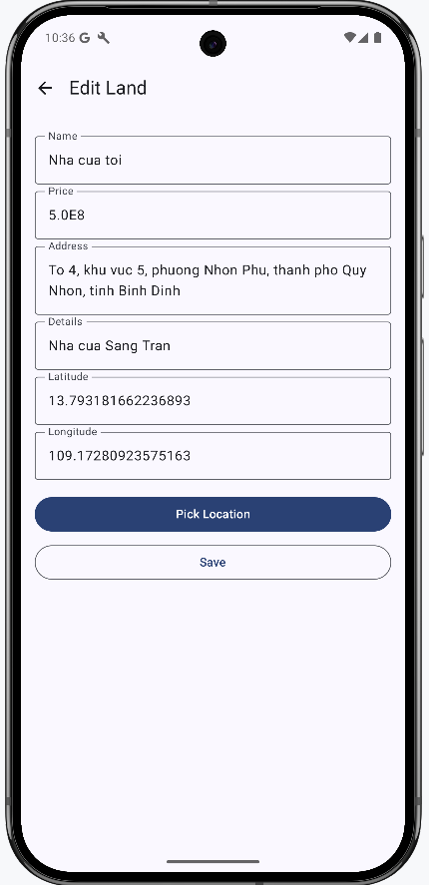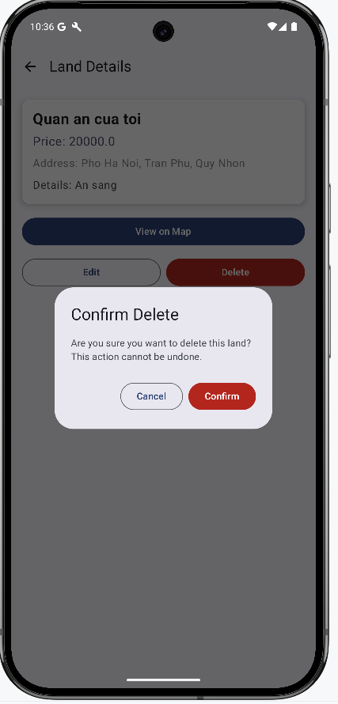

7. Conclusion
The Real Estate Management App effectively simplifies the process of managing land records. It ensures easy data entry, seamless updates, and location tracking via Google Maps. Future improvements may include cloud storage integration and user authentication for enhanced security.

Submitted By: Tran Ngoc Sang
Date: 13/03/2025

